Command Reference: FillRiverNetworkNode()

Fill river network node data

StateMod Command
Version 3.09.01, 2010-02-01

The FillRiverNetworkNode() command fills missing values in existing river network nodes. The following dialog is used to edit the command and illustrates the syntax of the command.

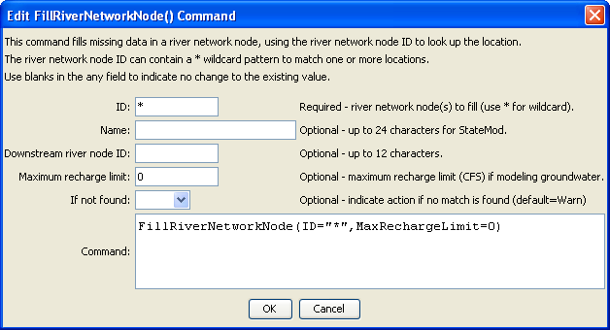
FillRiverNetworkNode
FillRiverNetworkNode() Command Editor

The command syntax is as follows:

FillRiverNetworkNode(Parameter=Value,…)

Command Parameters

Parameter | Description | Default
ID | A single river network node identifier to match or a pattern using wildcards (e.g., 20*). | None – must be specified.
Name | The name to be assigned for all matching river network nodes. | If not specified, missing values will not be filled.
DownstreamRiverNodeID | The downstream river node identifier to be assigned for all matching river network nodes. | If not specified, missing values will not be filled.
MaxRechargeLimit | The maximum recharge limit, CFS, for groundwater modeling, assigned for all matching river network nodes. | If not specified, missing values will not be filled.
IfNotFound | Used for error handling, one of the following:  - Fail – generate a failure message if the ID is not matched  - Ignore – ignore (don’t add and don’t generate a message) if the ID is not matched  - Warn – generate a warning message if the ID is not matched | Warn

