Command Reference: FillStreamEstimateStation()

Fill stream estimate station data

StateMod Command
Version 3.09.01, 2010-02-01

The FillStreamEstimateStation() command fills missing data in existing stream estimate stations. The following dialog is used to edit the command and illustrates the syntax of the command.

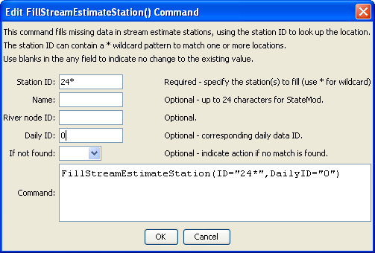
FillStreamEstimateStation
FillStreamEstimateStation() Command Editor

The command syntax is as follows:

FillStreamEstimateStation(Parameter=Value,…)

Command Parameters

Parameter | Description | Default
ID | A single stream estimate identifier to match or a pattern using wildcards (e.g., 20*). | None – must be specified.
RiverNodeID | The river node identifier to be assigned for all matching stream estimate identifiers with missing river node identifier | If not specified, the original value will remain.
DailyID | The daily identifier to be assigned for all matching stream estimate identifiers with missing river node identifier | If not specified, the original value will remain.
Name | The name to be assigned for all matching stream estimate identifiers with missing name. | If not specified, the original value will remain.
IfNotFound | Used for error handling, one of the following:  - Fail – generate a failure message if the ID is not matched  - Ignore – ignore (don’t add and don’t generate a message) if the ID is not matched  - Warn – generate a warning message if the ID is not matched | Warn

