Command Reference: FillStreamGageStation()

Fill stream gage station data

StateMod Command
Version 3.09.01, 2010-02-01

The FillStreamGageStation() command fills missing data in existing stream gage stations. The following dialog is used to edit the command and illustrates the syntax of the command.

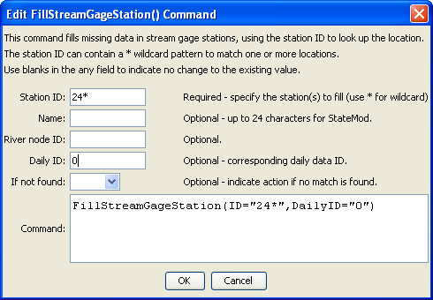
FillStreamGageStation
FillStreamGageStation() Command Editor

The command syntax is as follows:

FillStreamGageStation(Parameter=Value,…)

Command Parameters

Parameter | Description | Default
ID | A single stream gage identifier to match or a pattern using wildcards (e.g., 20*). | None – must be specified.
Name | The name to be assigned for all matching stream gage identifiers with missing name. | If not specified, the original value will remain.
RiverNodeID | The river node identifier to be assigned for all matching stream gage identifiers with missing river node identifier | If not specified, the original value will remain.
DailyID | The daily identifier to be assigned for all matching stream gage identifiers with missing river node identifier | If not specified, the original value will remain.
IfNotFound | Used for error handling, one of the following:  - Fail – generate a failure message if the ID is not matched  - Ignore – ignore (don’t add and don’t generate a message) if the ID is not matched  - Warn – generate a warning message if the ID is not matched | Warn

