Command Reference: FillStreamGageStationsFromNetwork()

Fill stream gage station data from a StateMod network

StateMod Command
Version 3.09.01, 2010-02-01

The FillStreamGageStationsFromNetwork() command fills missing data in stream gage stations, using a StateMod network for data. This command is usually used after filling from other sources (e.g., HydroBase), because the information in the network file may have been specified mainly for the diagram and therefore does not necessarily match official data sources. It is assumed that the network has been read in a previous command (e.g., when the list of stream gage stations was originally read).

The following dialog is used to edit the command and illustrates the syntax of the command.

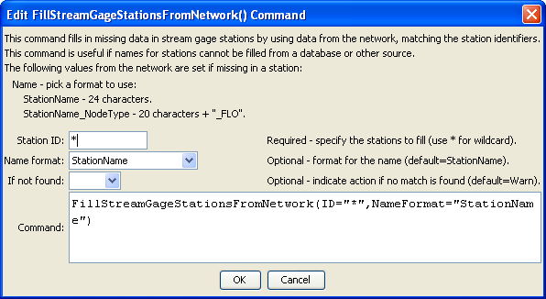
FllStreamGageStationsFromNetwork
FillStreamGageStationsFromNetwork() Command Editor

The command syntax is as follows:

FillStreamGageStationsFromNetwork(Parameter=Value,…)

Command Parameters

Parameter | Description | Default
ID | A single stream gage station identifier to match or a pattern using wildcards (e.g., 20*). | None – must be specified.
NameFormat | The format to use when setting the name, one of:  - StationName – use the station name from HydroBase  - StationName_NodeType – use the first 20 characters of the name from Hydrobase + “_” + the node type. | StationName
IfNotFound | Used for error handling, one of the following:  - Fail – generate a failure message if the ID is not matched  - Ignore – ignore (don’t add and don’t generate a message) if the ID is not matched  - Warn – generate a warning message if the ID is not matched | Warn

The following example command file illustrates the commands used to read stream gage stations from the network and create a StateMod file:

StartLog(LogFile="ris.commands.StateDMI.log")
# ris.commands.StateDMI
#
# StateDMI command file to create streamflow station file for the Colorado River
#
# Step 1 - read streamgages and baseflows ids from the network file
#
ReadStreamGageStationsFromNetwork(InputFile="..\Network\cm2005.net",
IncludeStreamEstimateStations="True")
#
# Step 2 - read baseflow nodes names from HydroBase,
# fill in missing names from the network file
#
FillStreamGageStationsFromHydroBase(ID="*",NameFormat=StationName,CheckStructures=True)
FillStreamGageStationsFromNetwork(ID="*",NameFormat="StationName")
#
# Step 3 - set streamgage station to use to disaggregate monthly baseflows to daily
#
# add set daily pattern gages for WD 36
SetStreamGageStation(ID="36*",DailyID="09047500",IfNotFound=Warn)
…many similar commands omitted…
#
# Step 4 - create streamflow station file
#
WriteStreamGageStationsToStateMod(OutputFile="..\StateMod\cm2005.ris")
#
# Check the results
CheckStreamGageStations(ID="*")
WriteCheckFile(OutputFile="ris.commands.StateDMI.check.html")

