Command Reference: FillWellHistoricalPumpingTSMonthlyConstant()

Fill well historical pumping time series (monthly) values using a constant value

StateCU and StateMod Command
Version 3.09.01, 2010-01-27

The FillWellHistoricalPumpingTSMonthlyConstant() command fills missing well historical pumping time series (monthly) data, using a constant value. This command is useful, for example, to set pumping values to zero if other fill commands are unable to provide data estimates for missing data.

The following dialog is used to edit the command and illustrates the syntax of the command.

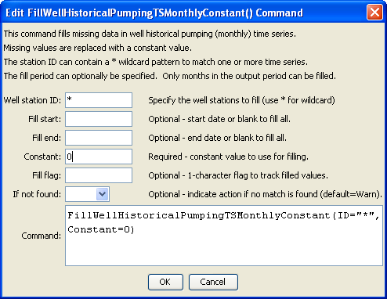
FilltWellHistoricalPumpingTSMonthlyConstant
FillWellHistoricalPumpingTSMonthlyConstant() Command Editor

The command syntax is as follows:

FillWellHistoricalPumpingTSMonthlyConstant(Parameter=Value,…)

Command Parameters

Parameter | Description | Default
ID | A single well station identifier to match or a pattern using wildcards (e.g., 20*). | None – must be specified.
FillStart | The first year to fill, using format YYYY-MM or MM/YYYY. | If not specified, fill the full period.
FillEnd | The last year to fill, using format YYYY-MM or MM/YYYY. | If not specified, fill the full period.
Constant | The constant value to be used to fill missing data. | None – must be specified.
FillFlag | If specified as a single character, data flags will be enabled for the time series and each filled value will be tagged with the specified character. The flag can then be used later to label graphs, etc. The flag will be appended to existing flags if necessary. | No flag is assigned.
IfNotFound | Used for error handling, one of the following:  - Fail – generate a failure message if the ID is not matched  - Ignore – ignore (don’t generate a message) if the ID is not matched  - Warn – generate a warning message if the ID is not matched | Warn

