Command Reference: FillWellStationsFromDiversionStations ()

Fill well station data using diversion stations

StateMod Command
Version 3.09.01, 2010-02-01

The FillWellStationsFromDiversionStations() command fills missing well station data for each location, using the corresponding diversion station (only for D&W model nodes). The diversion stations must have been read or assigned with previous commands. The following data are filled: name, demand source, demand type, use type.

The following dialog is used to edit the command and illustrates the syntax of the command.

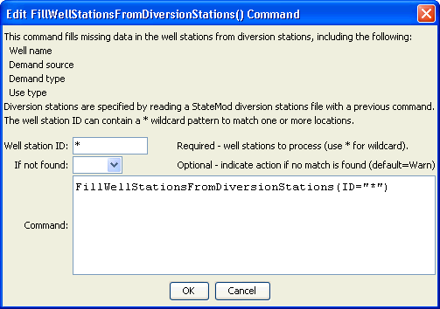
FillWellStationsFromDiversionStations
FillWellStationsFromDiversionStations() Command Editor
The command syntax is as follows:

FillWellStationsFromDiversionStations(Parameter=Value,…)

Command Parameters

Parameter | Description | Default
ID | A single well station identifier to match or a pattern using wildcards (e.g., 20*). | None – must be specified.
IfNotFound | Used for error handling, one of the following:  - Fail – generate a failure message if the ID is not matched  - Ignore – ignore (don’t add and don’t generate a message) if the ID is not matched  - Warn – generate a warning message if the ID is not matched | Warn

