Command Reference: MergeListFileColumns()

Merge columns in a list file and write a new list file

General Command
Version 3.09.00, 2010-01-16

The MergeListFileColumns() command reads a comma-delimited list file, uses information from existing columns to create a new column, and writes the new list file. As currently implemented, whitespace will be trimmed from the original data. This command is useful for example, if the WD and ID columns in a file need to be merged into a WDID column.

The following dialog is used to edit the command and illustrates command syntax:

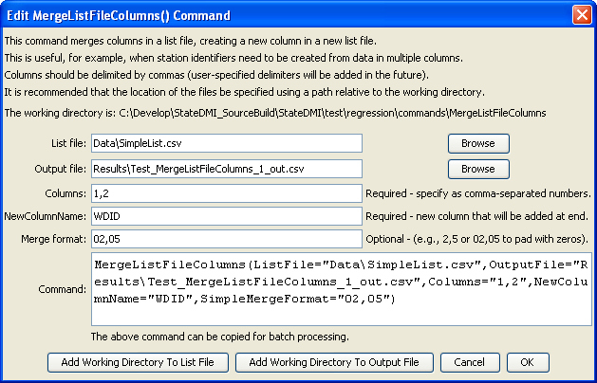
MergeListFileColumns
MergeListFileColumns() Command Editor

The command syntax is as follows:

MergeListFileColumns(Parameter=Value,…)

Command Parameters

Parameter | Description | Default
ListFile | The name of the list file to read. | None – must be specified.
OutputFile | The name of the output list file to create. This file will have the same contents as the original file, with the new column at the end. | None – must be specified.
Columns | A comma-separated list of columns to merge. Column numbers have a value ≥ 1. | None – must be specified.
NewColumnName | Name of the column to be created, which will be added at the end of the original columns. | None – must be specified.
SimpleMergeFormat | Comma-separated list of formats indicating how to format the merged column, one of the following:  - Blank – concatenate the values.  - NN,NN (e.g., 2,5) – indicate the widths for each part and merge as strings where each part is right justified and padded with spaces.  - 0N,0N (e.g., 02,05) – indicate the widths for each part and merge as integers where each part is right justified and padded with zeros.  A more flexible formatting capability may be added in the future. | Concatenate values.

The following example concatenates the WD and ID columns into a single WDID column by padding with zeros. The first row of the list file should contain double-quoted column headers.

MergeListFileColumns(ListFile="poudre1.csv",OutputFile="poudre2.csv",
Columns="2,3",NewColumnName="WDID",SimpleMergeFormat="02,05")

