Command Reference: ReadBlaneyCriddleFromHydroBase()

Read Blaney-Criddle crop coefficients data from HydroBase

StateCU Command
Version 3.08.02, 2010-01-07

The ReadBlaneyCriddleFromHydroBase() command reads a list of Blaney-Criddle crop coefficients from the HydroBase database. The crop coefficients can then be manipulated and output with other commands. The following dialog is used to edit the command and illustrates the syntax of the command.

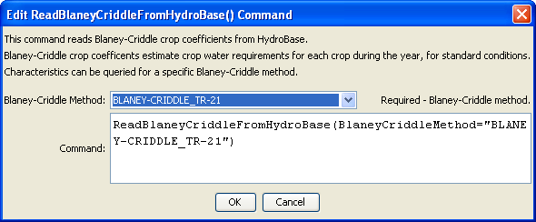
ReadBlaneyCriddleFromHydroBase
ReadBlaneyCriddleFromHydroBase() Command Editor

The command syntax is as follows:

ReadBlaneyCriddleFromHydroBase(Parameter=Value,…)

Command Parameters

Parameter | Description | Default
BlaneyCriddleMethod | The Blaney-Criddle method that is defined in HydroBase for the crop type and its coefficients. | None – must be specified.

The crop type (e.g., ALFALFA) is used as the unique identifier. Any previous crop coefficients objects will be added to (or replaced if identifiers match).

The BlaneyCriddleMethod parameter corresponds to a value in HydroBase and allows regional crop characteristics to be defined.

The following example command file illustrates how to read Blaney-Criddle coefficients from HydroBase, sort the data, create a StateCU file, and check the results:

StartLog(LogFile="Crops_KBC.StateDMI.log")
#
# StateDMI commands to create the Rio Grande Blaney-Criddle coefficients File
#
# History:
#
# 2004-03-16 Steven A. Malers, RTi Initial version using StateDMI.
# 2007-04-23 SAM, RTi Update for Rio Grande Phase 5.
#
# Step 1 - read data from HydroBase
#
# Read the general Blaney-Criddle coefficients first and then override with Rio Grande
# data.
ReadBlaneyCriddleFromHydroBase(BlaneyCriddleMethod="BLANEY-CRIDDLE_TR-21")
ReadBlaneyCriddleFromHydroBase(BlaneyCriddleMethod="BLANEY-CRIDDLE_RIO_GRANDE")
#
# Step 3 - write the file
#
SortBlaneyCriddle(Order=Ascending)
WriteBlaneyCriddleToStateCU(OutputFile="rg2007.kbc")
#
# Check the results
#
CheckBlaneyCriddle(ID="*")
WriteCheckFile(OutputFile="rg2007.kbc.check.html")

