Command Reference: ReadBlaneyCriddleFromStateCU()

Read Blaney-Criddle crop coefficients data from a StateCU Blaney-Criddle crop coefficients file

StateCU Command
Version 3.08.02, 2010-01-07

The ReadBlaneyCriddleFromStateCU() command reads Blaney-Criddle crop coefficients from a StateCU Blaney-Criddle crop coefficients file and defines crop coefficients in memory. The crop coefficients can then be manipulated and output with other commands. This command can be used to adjust an existing crop coefficients file. The following dialog is used to edit the command and illustrates the syntax of the command.

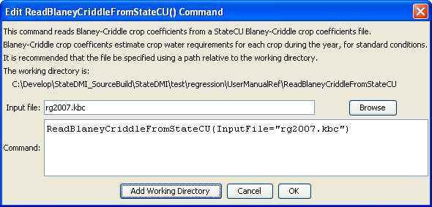
ReadBlaneyCriddleFromStateCU
ReadBlaneyCriddleFromStateCU() Command Editor

The command syntax is as follows:

ReadBlaneyCriddleFromStateCU(Parameter=Value,…)

Command Parameters

Parameter | Description | Default
InputFile | The name of the input file to read, surrounded by double quotes. | None – must be specified.

