Command Reference: ReadCULocationsFromStateCU()

Read CU Locations data from a StateCU structure file

StateCU Command
Version 3.08.02, 2010-01-07

The ReadCULocationsFromStateCU() command reads a list of CU Locations from a StateCU structure file and defines CU Locations in memory. The CU Locations can then be manipulated and output with other commands. This command can be used to adjust an existing CU Locations file. The following dialog is used to edit the command and illustrates the syntax of the command.

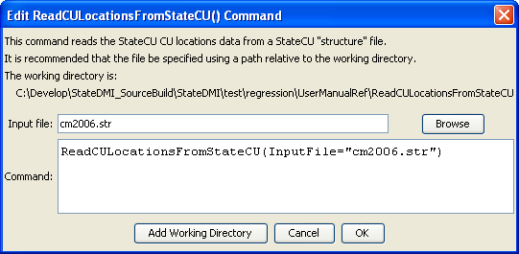
ReadCULocationssFromStateCU
ReadCULocationsFromStateCU() Command Editor

The command syntax is as follows:

ReadCULocationsFromStateCU(Parameter=Value,…)

Command Parameters

Parameter | Description | Default
InputFile | The name of the input file to read, surrounded by double quotes. | None – must be specified.

