Command Reference: ReadCULocationsFromStateMod()

Read CU Locations data from a StateMod diversion or well stations file

StateCU Command
Version 3.08.02, 2010-01-02

The ReadCULocationsFromStateMod() command reads a list of CU Locations from a StateMod diversion or well stations file and defines CU Locations in memory. The CU Locations can then be manipulated and output with other commands. The following dialog is used to edit the command and illustrates the syntax of the command.

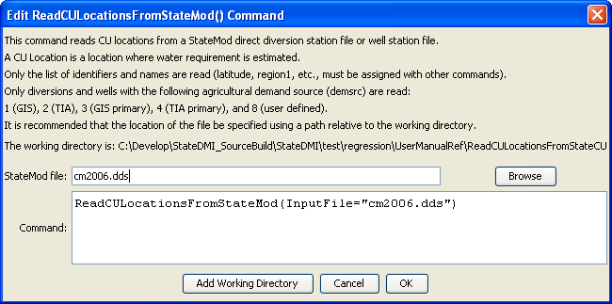
ReadCULocationssFromStateMod
ReadCULocationsFromStateMod() Command Editor

The command syntax is as follows:

ReadCULocationsFromStateMod(Parameter=Value,…)

Command Parameters

Parameter | Description | Default
InputFile | The name of the input file to read, surrounded by double quotes. | None – must be specified.

