Command Reference: ReadClimateStationsFromList()

Read climate station data from a list file to define climate stations

StateCU Command
Version 03.08.02, 2010-01-05

The ReadClimateStationsFromList() command reads a list of climate stations from a delimited list file and defines climate stations in memory. The climate stations can then be manipulated and output with other commands. The following dialog is used to edit the command and illustrates the syntax of the command.

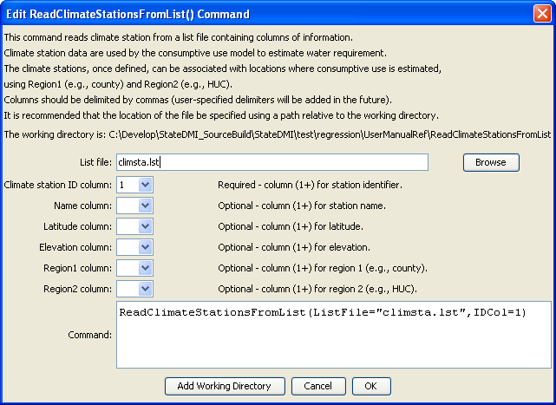
ReadClimateStationsFromList
ReadClimateStationsFromList() Command Editor

The command syntax is as follows:

ReadClimateStationsFromList(Parameter=Value,…)

Command Parameters

Parameter | Description | Default
ListFile | The name of the list file to be read. | None – must be specified.
IDCol | The column number (1+) containing the climate station identifiers. | None – must be specified.
NameCol | The column number (1+) containing the climate station name. | None – optional (name will be initialized to blank).
LatitudeCol | The column number (1+) containing the climate station latitude. | None – optional (latitude will be initialized to missing data).
ElevationCol | The column number (1+) containing the climate station elevation. | None – optional (elevation will be initialized to missing data).
Region1Col | The column number (1+) containing the climate station Region1. | None – optional (Region1 will be initialized to blank).
Region2Col | The column number (1+) containing the climate station Region2. | None – optional (Region2 will be initialized to blank).

At a minimum, the list file must contain a column with station identifiers. Lines starting with the # character are treated as commas. Column names can be specified in the first non-comment line by enclosing each column name in quotes.

An example list file is shown below, for example created from CDSS TSTool software:

# Climate stations
“ID”,”Name”
0130,” ALAMOSA SAN LUIS VALLEY RGNL”
0776,”BLANCA”
1458,” CENTER 4 SSW”
2184,” DEL NORTE 2 E”
3541,” GREAT SAND DUNES N M”
3951,” HERMIT 7 ESE”
5322,” MANASSA”
5706,” MONTE VISTA 2 W”
7337,” SAGUACHE”

The following example command file illustrates how climate stations can be defined from a list and written to a StateCU file:

ReadClimateStationsFromList(ListFile="climsta.lst",IDCol=1)
FillClimateStationsFromHydroBase(ID="*")
SetClimateStation(ID="3016",Region2="14080106",IfNotFound=Warn)
SetClimateStation(ID="1018",Region2="14040106",IfNotFound=Warn)
SetClimateStation(ID="1928",Elevation=6440,IfNotFound=Warn)
SetClimateStation(ID="0484",Region1="MOFFAT",IfNotFound=Add)
WriteClimateStationsToStateCU(OutputFile="COclim2006.cli")

