Command Reference: ReadClimateStationsFromStateCU()

Read climate station data from a StateCU climate stations file to define climate stations

StateCU Command
Version 3.08.02, 2010-01-05

The ReadClimateStationsFromStateCU() command reads a list of climate stations from a StateCU climate stations file and defines climate stations in memory. The climate stations can then be manipulated and output with other commands. This command can be used to adjust an existing climate stations file. The following dialog is used to edit the command and illustrates the syntax of the command.

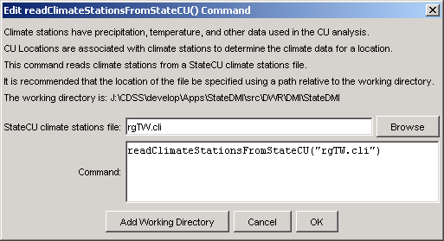
ReadClimateStationsFromStateCU
ReadClimateStationsFromStateCU() Command Editor

The command syntax is as follows:

ReadClimateStationsFromStateCU(Parameter=Value,…)

Command Parameters

Parameter | Description | Default
InputFile | The name of the input file to read, surrounded by double quotes. | None – must be specified.

The following example command file illustrates how climate stations can be read from a StateCU file:

ReadClimateStationsFromStateCU(InputFile="COclim2006.cli")

