Command Reference: ReadControlFromStateMod()

Read control file data from a StateMod control file

StateMod Command
Version 3.12.00, 2011-01-17

The ReadControlFromStateMod() command reads a StateMod control file, which contains global parameters for the data set. The primary purpose of this command currently is to facilitate software testing of reading and writing the control file; however, in the future the functionality may be enhanced. The response file can be written using the WriteControlToStateMod() command.

The following dialog is used to edit the command and illustrates the syntax of the command.

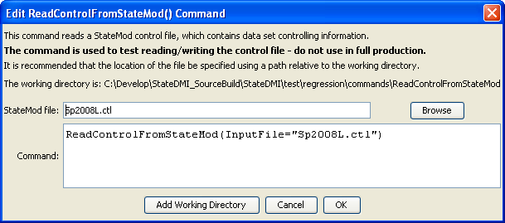
ReadControlFromStateMod
ReadControlFromStateMod() Command Editor

The command syntax is as follows:

ReadControlFromStateMod(Parameter=Value,…)

Command Parameters

Parameter | Description | Default
InputFile | The name of the StateMod control file to read. | None – must be specified.

