Command Reference: ReadCropCharacteristicsFromStateCU()

Read crop characteristics data from a StateCU crop characteristics file

StateCU Command
Version 3.08.02, 2010-01-07

The ReadCropCharacteristicsFromStateCU() command reads a list of crops and their characteristics from a StateCU crop characteristics file and defines crop characteristics in memory. The crop characteristics can then be manipulated and output with other commands. This command can be used to adjust an existing crop characteristics file. The following dialog is used to edit the command and illustrates the syntax of the command.

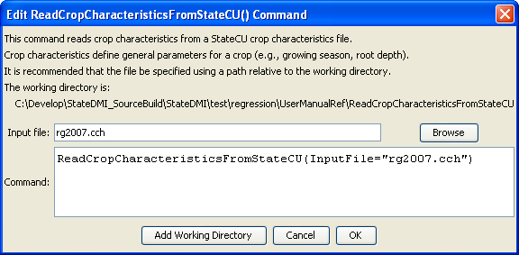
ReadCropCharacteristicsFromStateCU
ReadCropCharacteristicsFromStateCU() Command Editor

The command syntax is as follows:

ReadCropCharacteristicsFromStateCU(Parameter=Value,…)

Command Parameters

Parameter | Description | Default
InputFile | The name of the input file to read, surrounded by double quotes. | None – must be specified.

