Command Reference: ReadCropPatternTSFromHydroBase()

Read crop pattern time series data from HydroBase

StateCU Command
Version 3.09.01, 2010-02-01

The ReadCropPatternTSFromHydroBase() command reads crop pattern time series from HydroBase and defines crop pattern time series in memory. The crop pattern time series can then be manipulated and output with other commands. If a CU Location is a diversion, the crop pattern data are read from HydroBase tables that contain irrigated acres for the ditch service area. If the CU Location is an aggregate of parcels, the area is determined from the parcel data.

When processing crop pattern time series, data from HydroBase may need to be combined with user-specified data. A single location or location that is part of an aggregate/system can have its data specified with a SetCropPatternTS(…,ProcessWhen=WithParcels,…) or SetCropPatternTSFromList(…,ProcessWhen=WithParcels,…) command. In this case, it is expected that the acreage will not be found in HydroBase. Use set commands before the ReadCropPatternTSFromHydroBase() command. It is recommended that a SetCropPatternTSFromList(…,ProcessWhen=WithParcels,…) command be used for each year of HydroBase data that is processed.

The following dialog is used to edit the command and illustrates the syntax of the command.

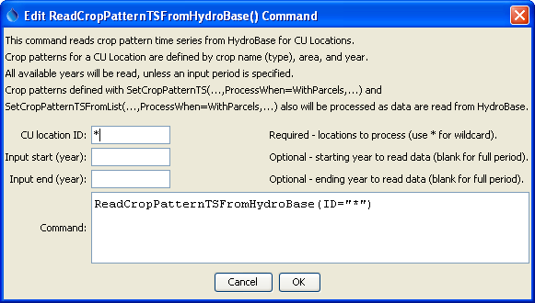
ReadCropPatternTSFromHydroBase_True
ReadCropPatternTSFromHydroBase() Command Editor

The command syntax is as follows:

ReadCropPatternTSFromHydroBase(Parameter=Value,…)

Command Parameters

Parameter | Description | Default
ID | A single CU Location identifier to match or a pattern using wildcards (e.g., 20*). | None – must be specified.
InputStart | Starting year to read data. | All available data will be read.
InputEnd | Ending year to read data. | All available data will be read.

The following command file illustrates how to create a crop pattern time series file:

# Step 1 - Set output period and read CU locations
SetOutputPeriod(OutputStart="1950",OutputEnd="2006")
ReadCULocationsFromStateCU(InputFile="..\StateCU\cm2006.str")
# Step 2 - Read SW aggregates
SetDiversionSystemFromList(ListFile="colorado_divsys.csv",IDCol=1,
NameCol=2,PartIDsCol=3,PartsListedHow=InRow)
SetDiversionAggregateFromList(ListFile="colorado_agg.csv",IDCol=1,
NameCol=2,PartIDsCol=3,PartsListedHow=InRow)
# Step 3 - Create *.cds file form and read acreage/crops from HydroBase
CreateCropPatternTSForCULocations(ID="*",Units="ACRE")
ReadCropPatternTSFromHydroBase(ID="*")
# Step 4 - Need to translate crops out of HB to include TR21 suffix
# Translate all crops from HB to include .TR21 suffix
TranslateCropPatternTS(ID="*",OldCropType="GRASS_PASTURE",NewCropType="GRASS_PASTURE.TR21")
TranslateCropPatternTS(ID="*",OldCropType="CORN_GRAIN",NewCropType="CORN_GRAIN.TR21")
TranslateCropPatternTS(ID="*",OldCropType="ALFALFA",NewCropType="ALFALFA.TR21")
TranslateCropPatternTS(ID="*",OldCropType="SMALL_GRAINS",NewCropType="SPRING_GRAIN.TR21")
TranslateCropPatternTS(ID="*",OldCropType="VEGETABLES",NewCropType="VEGETABLES.TR21")
TranslateCropPatternTS(ID="*",OldCropType="ORCHARD_WO_COVER",NewCropType="ORCHARD_WO_COVER.TR21")
TranslateCropPatternTS(ID="*",OldCropType="ORCHARD_WITH_COVER",NewCropType="ORCHARD_WITH_COVER.TR21")
TranslateCropPatternTS(ID="*",OldCropType="DRY_BEANS",NewCropType="DRY_BEANS.TR21")
TranslateCropPatternTS(ID="*",OldCropType="GRAPES",NewCropType="GRAPES.TR21")
TranslateCropPatternTS(ID="*",OldCropType="WHEAT",NewCropType="SPRING_GRAIN.TR21")
TranslateCropPatternTS(ID="*",OldCropType="SUNFLOWER",NewCropType="SPRING_GRAIN.TR21")
TranslateCropPatternTS(ID="*",OldCropType="SOD_FARM",NewCropType="GRASS_PASTURE.TR21")
# Step 5 - Translate crop names
# use high-altitude coefficients for structures with more than 50% of
# irrigated acreage above 6500 feet
TranslateCropPatternTS(ListFile="cm2005_HA.lst",IDCol=1,
OldCropType="GRASS_PASTURE.TR21",NewCropType="GRASS_PASTURE.DWHA")
# Step 6 - Fill Acreage
# Fill SW structure acreage backword from 1999 to 1950
# Fill acreage forward for all structures from 2000 to 2006
FillCropPatternTSRepeat(ID="*",CropType="*",FillStart=1950,FillEnd=1993,FillDirection=Backward)
FillCropPatternTSRepeat(ID="*",CropType="*",FillStart=1993,FillEnd=1999,FillDirection=Forward)
FillCropPatternTSRepeat(ID="*",CropType="*",FillStart=2000,FillEnd=2006,FillDirection=Forward)
# Step 7 - Write final *.cds file
WriteCropPatternTSToStateCU(OutputFile="..\StateCU\cm2006.cds",
WriteCropArea=True,WriteHow=OverwriteFile)
# Check the results
CheckCropPatternTS(ID="*")
WriteCheckFile(OutputFile="cm2006.cds.StateDMI.check.html")

