Command Reference: ReadDelayTablesMonthlyFromStateMod()

Read delay tables (monthly) data from a StateMod file

StateCU, StateMod Command
Version 3.09.01, 2010-02-01

The ReadDelayTablesMonthlyFromStateMod() command reads delay tables (monthly) from a StateMod delay tables file. For example, this command may be used to convert a delay table file between fraction and percent.

The following dialog is used to edit the command and illustrates the syntax of the command.

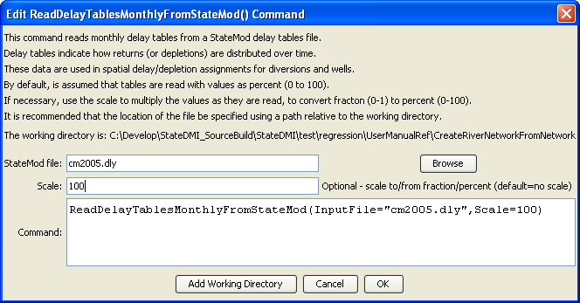
ReadDelayTablesMonthlyFromStateMod
ReadDelayTablesMonthlyFromStateMod() Command Editor

The command syntax is as follows:

ReadDelayTablesMonthlyFromStateMod(Parameter=Value,…)

Command Parameters

Parameter | Description | Default
InputFile | The name of the input file to read, surrounded by double quotes. | None – must be specified.
Scale | If the StateMod delay table values are specified as fractions rather than percent, a scale of 100 can be used to convert the StateMod delay tables to percent. | If not specified, no scale is applied to the delay values.

