Command Reference: ReadDiversionDemandTSMonthlyFromStateMod()

Read diversion demand time series (monthly) data from a StateMod file

StateMod Command
Version 3.09.01, 2010-02-01

The ReadDiversionDemandTSMonthlyFromStateMod() command reads diversion demand time series (monthly). All time series are read, whether or not they match the list of diversion stations.

The following dialog is used to edit the command and illustrates the syntax of the command.

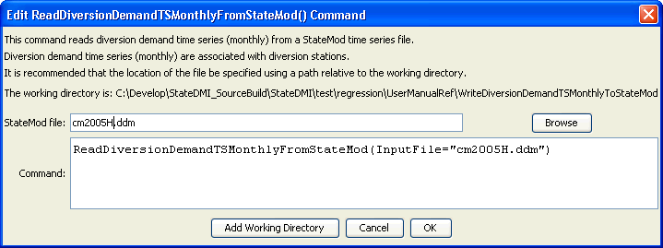
ReadDiversionDemandTSMonnthlyFromStateMod
ReadDiversionDemandTSMonthlyFromStateMod() Command Editor

The command syntax is as follows:

ReadDiversionDemandTSMonthlyFromStateMod(Parameter=Value,…)

Command Parameters

Parameter | Description | Default
InputFile | The name of the StateMod diversion demand time series (monthly) file to read. | None – must be specified.

