Command Reference: ReadDiversionHistoricalTSMonthlyFromStateMod()

Read diversion historical time series (monthly) data from a StateMod file

StateMod Command
Version 3.09.01, 2010-02-01

The ReadDiversionHistoricalTSMonthlyFromStateMod() command reads diversion historical time series (monthly). This command is used when estimating average efficiencies and calculating demand time series. All time series are read, whether or not they match the list of diversion stations. Copies of the time series are NOT made for use as original data with the Limit*ToRights() commands.

The following dialog is used to edit the command and illustrates the syntax of the command.

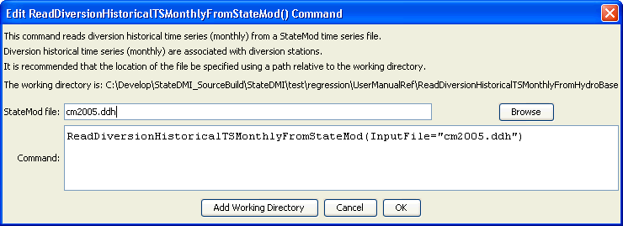
ReadDiversionHistoricalTSMonnthlyFromStateMod
ReadDiversionHistoricalTSMonthlyFromStateMod() Command Editor

The command syntax is as follows:

ReadDiversionHistoricalTSMonthlyFromStateMod(Parameter=Value,…)

Command Parameters

Parameter | Description | Default
InputFile | The name of the StateMod diversion historical time series (monthly) file to read. | None – must be specified.

