Command Reference: ReadDiversionRightsFromStateMod()

Read diversion right data from a StateMod diversion rights file

StateCU and StateMod Command
Version 3.09.00, 2010-01-26

The ReadDiversionRightsFromStateMod() command reads diversion rights from a StateMod diversion rights file. The diversion rights can then be manipulated and output with other commands.

The following dialog is used to edit the command and illustrates the syntax of the command.

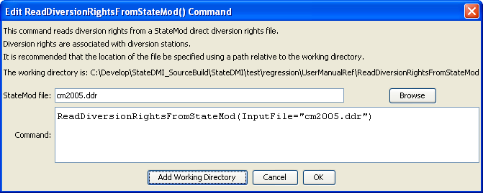
ReadDiversionRightsFromStateMod
ReadDiversionRightsFromStateMod() Command Editor

The command syntax is as follows:

ReadDiversionRightsFromStateMod(Parameter=Value,…)

Command Parameters

Parameter | Description | Default
InputFile | The name of the StateMod diversion rights file to be read. | None – must be specified.

