Command Reference: ReadDiversionStationsFromList()

Read diversion stations data from a list file

StateCU and StateMod Command
Version 3.09.01, 2010-01-26

The ReadDiversionStationsFromList() command reads a list of diversion stations from a delimited list file and defines diversion stations in memory. The diversion stations can then be manipulated and output with other commands. The following dialog is used to edit the command and illustrates the syntax of the command.

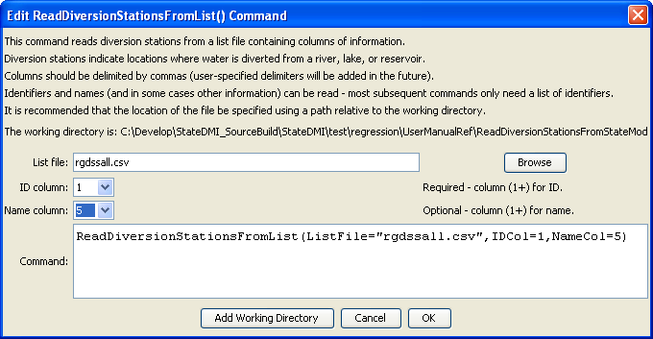
ReadDiversionStationsFromList
ReadDiversionStationsFromList() Command Editor

The command syntax is as follows:

ReadDiversionStationsFromList(Parameter=value,…)

Command Parameters

Parameter | Description | Default
ListFile | The name of the list file to be read. | None – must be specified.
IDCol | The column number (1+) containing the diversion station identifiers. | None – must be specified.
NameCol | The column number (1+) containing the diversion station names. | None – optional (name will be initialized to blank).

At a minimum, the list file must contain a column with diversion station identifiers. Lines starting with the # character are treated as comments. If the first line’s values are surrounded by double quotes, the line is assumed to indicate column headings.

A sample list file is shown below:

# Diversions as list file
#
#
"ID","Latitude","County","HUC","Name"
200505,37.5,ALAMOSA,13010002,ALAMOSA D
200511,37.68,RIO GRANDE,13010001,ANACONDA D
200512,37.61,RIO GRANDE,13010002,ANDERSON D
200513,37.68,RIO GRANDE,13010002,ANNA RABER D
…

