Command Reference: ReadDiversionStationsFromNetwork()

Read diversion station data from a network file

StateCU and StateMod Command
Version 3.09.00, 2010-01-26

The ReadDiversionStationsFromNetwork() command reads a list of diversion stations from a StateMod network file (XML or Makenet) and defines diversion stations in memory. The diversion stations can then be manipulated and output with other commands.

The following dialog is used to edit the command and illustrates the syntax of the command.

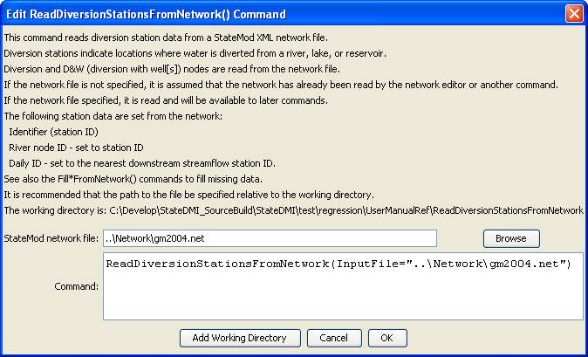
ReadDiversionStationsFromNetwork
ReadDiversionStationsFromNetwork() Command Editor

The command syntax is as follows:

ReadDiversionStationsFromNetwork(Parameter=Value,…)

Command Parameters

Parameter | Description | Default
InputFile | The name of the network file to be read. | None – must be specified.

