Command Reference: ReadDiversionStationsFromStateMod()

Read diversion station data from a StateMod diversion stations file

StateCU and StateMod Command
Version 3.09.00, 2010-01-26

The ReadDiversionStationsFromStateMod() command reads a list of diversion stations from a StateMod diversion stations file and defines diversion stations in memory. The diversion stations can then be manipulated and output with other commands.

The following dialog is used to edit the command and illustrates the syntax of the command.

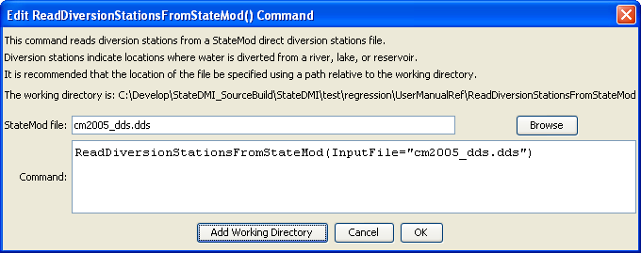
ReadDiversionStationsFromStateMod
ReadDiversionStationsFromStateMod() Command Editor

The command syntax is as follows:

ReadDiversionStationsFromStateMod(Parameter=Value,…)

Command Parameters

Parameter | Description | Default
InputFile | The name of the StateMod diversion stations file to be read. | None – must be specified.

