Command Reference: ReadInstreamFlowDemandTSAverageMonthlyFromStateMod()

Read instream flow demand time series (average monthly) data from a StateMod instream flow demand time series (average monthly) file

StateMod Command
Version 3.09.01, 2010-02-02

The ReadInstreamFlowDemandTSAverageMonthlyFromStateMod() command reads instream flow demand time series (average monthly) from a StateMod instream flow demand time series (average monthly) file. The instream flow demand time series can then be manipulated and output with other commands.

The following dialog is used to edit the command and illustrates the syntax of the command.

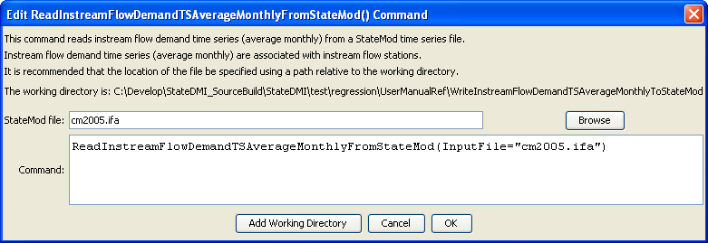
ReadInstreamFlowDemandTSAverageMonthlyFromStateMod
ReadInstreamFlowDemandTSAverageMonthlyFromStateMod() Command Editor

The command syntax is as follows:

ReadInstreamFlowDemandTSAverageMonthlyFromStateMod(Parameter=Value,…)

Command Parameters

Parameter | Description | Default
InputFile | The name of the StateMod instream flow demand time series (average monthly) file to be read. | None – must be specified.

