Command Reference: ReadInstreamFlowRightsFromStateMod()

Read instream flow right data from a StateMod instream flow rights file

StateMod Command
Version 3.09.01, 2010-02-02

The ReadInstreamFlowRightsFromStateMod() command reads instream flow rights from a StateMod instream flow rights file. The instream flow rights can then be manipulated and output with other commands.

The following dialog is used to edit the command and illustrates the syntax of the command.

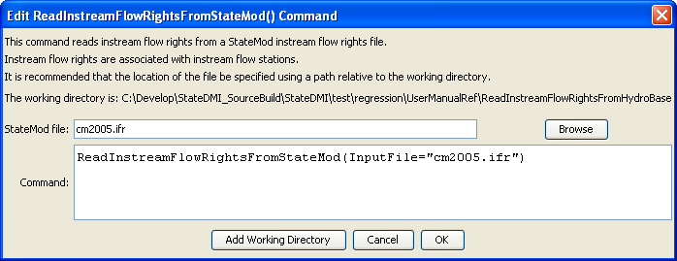
ReadInstreamFlowRightsFromStateMod
ReadInstreamFlowRightsFromStateMod() Command Editor

The command syntax is as follows:

ReadInstreamFlowRightsFromStateMod(Parameter=Value,…)

Command Parameters

Parameter | Description | Default
InputFile | The name of the StateMod instream flow rights file to be read. | None – must be specified.

