Command Reference: ReadInstreamFlowStationsFromList()

Read instream flow station data from a list file

StateMod Command
Version 3.09.01, 2010-02-01

The ReadInstreamFlowStationsFromList() command reads a list of instream flow stations from a delimited list file and defines instream flow stations in memory. The instream flow stations can then be manipulated and output with other commands. The following dialog is used to edit the command and illustrates the syntax of the command.

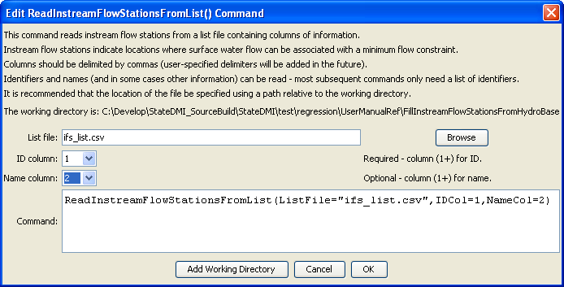
ReadInstreamFlowStationsFromList
ReadInstreamFlowStationsFromList() Command Editor

The command syntax is as follows:

ReadInstreamFlowStationsFromList(Parameter=Value,…)

Command Parameters

Parameter | Description | Default
ListFile | The name of the list file to be read. | None – must be specified.
IDCol | The column number (1+) containing the stream gage station identifiers. | None – must be specified.
NameCol | The column number (1+) containing the stream gage station names. | None – optional (name will be initialized to blank).

At a minimum, the list file must contain a column with instream flow station identifiers. Lines starting with the # character are treated as comments. If the first line’s values are surrounded by double quotes, the line is assumed to indicate column headings.

A sample list file is shown below:

# Stream gage stations as a list file
#
"ID”,"Name"
IFS1,”INSTREAM FLOW REACH 1”
IFS2,”INSTREAM FLOW REACH 2”
…

