Command Reference: ReadInstreamFlowStationsFromNetwork()

Read instream flow station data from a network file

StateMod Command
Version 3.09.01, 2010-02-01

The ReadInstreamFlowStationsFromNetwork() command reads a list of instream flow stations from a StateMod network file (XML or old Makenet) and defines instream flow stations in memory. The instream flow stations can then be manipulated and output with other commands. Instream flow stations are actually modeled as a reach defined by upstream and downstream nodes. Both nodes must be included in the network but the instream flow station file has a single record for each reach.

The following dialog is used to edit the command and illustrates the syntax of the command.

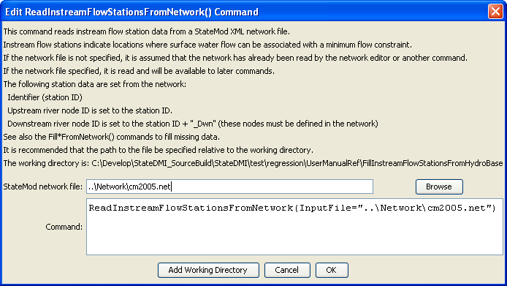
ReadInstreamFlowStationsFromNetwork
ReadInstreamFlowStationsFromNetwork() Command Editor

The command syntax is as follows:

ReadInstreamFlowStationsFromNetwork(Parameter=Value,…)

Command Parameters

Parameter | Description | Default
InputFile | The name of the network file to be read. | None – must be specified.

