Command Reference: ReadInstreamFlowStationsFromStateMod()

Read instream flow station data from a StateMod instream flow stations file

StateMod Command
Version 3.09.01, 2010-02-01

The ReadInstreamFlowStationsFromStateMod() command reads a list of instream flow stations from a StateMod instream flow stations file and defines instream flow stations in memory. The instream flow stations can then be manipulated and output with other commands.

The following dialog is used to edit the command and illustrates the syntax of the command.

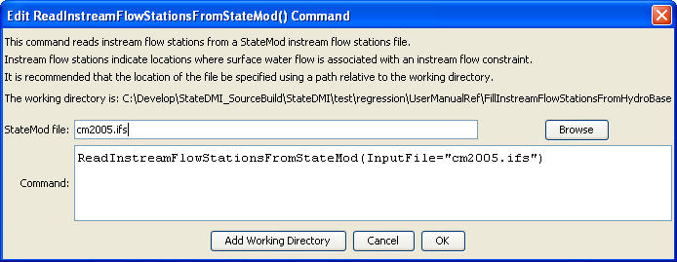
ReadInstreamFlowStationsFromStateMod
ReadInstreamFlowStationsFromStateMod() Command Editor

The command syntax is as follows:

ReadInstreamFlowStationsFromStateMod(Parameter=Value,…)

Command Parameters

Parameter | Description | Default
InputFile | The name of the StateMod instream flow stations file to be read. | None – must be specified.

