Command Reference: ReadIrrigationPracticeTSFromStateCU()

Read irrigation practice time series data from a StateCU file

StateCU Command
Version 3.09.01, 2010-02-01

The ReadIrrigationPracticeTSFromStateCU() command reads irrigation practice time series data from a StateCU irrigation practice time series file and defines the data in memory. The irrigation practice time series can then be manipulated and output with other commands. This command can be used to adjust an existing irrigation practice file. See also the TSTool software, which can be used to read, manipulate, and view irrigation practice time series.

The following dialog is used to edit the command and illustrates the syntax of the command.

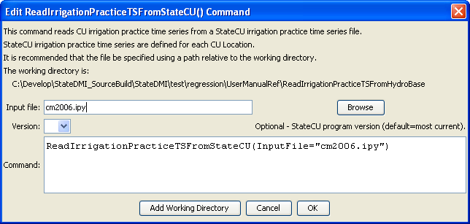
ReadIrrigationPracticeTSFromStateCU
ReadIrrigationPracticeTSFromStateCU() Command Editor

The command syntax is as follows:

ReadIrrigationPracticeTSFromStateCU(Parameter=Value,…)

Command Parameters

Parameter | Description | Default
InputFile | The name of the file to read, surrounded by double quotes. | None – must be specified.
Version | The StateCU version number, to allow backward compatibility with file formats from an earlier StateCU version. | Use the most current known format.

