Command Reference: ReadNetworkFromStateMod()

Read generalized network from a StateMod XML network file

StateMod Command
Version 3.09.01, 2010-02-01

The ReadNetworkFromStateMod() command reads the generalized network from a StateMod XML network file. The network can then be manipulated and utilized by other commands. Normally the generalized network is edited interactively in StateDMI (or StateMod GUI) and is used to generate lists of stations, for further processing. However, this command can be used to read the network and allow manipulation based on river upstream/downstream connectivity. See also commands like ReadDiversionStationsFromNetwork(), which read a subset of the network, to facilitate creation of specific model data files.

The following dialog is used to edit the command and illustrates the syntax of the command.

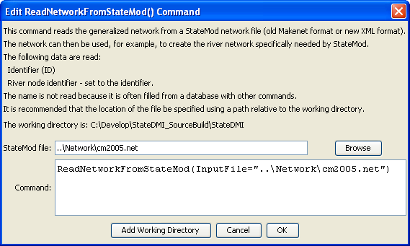
ReadNetworkFromStateMod
ReadNetworkFromStateMod() Command Editor

The command syntax is as follows:

ReadNetworkFromStateMod(Parameter=Value,…)

Command Parameters

Parameter | Description | Default
InputFile | The name of the StateMod XML network file to read. | None – must be specified.

