Command Reference: ReadOperationalRightsFromStateMod()

Read operational right data from a StateMod operational rights file

StateMod Command
Version 3.12.00, 2010-12-14

The ReadOperationalRightsFromStateMod() command reads a list of operational rights from a StateMod operational rights file and defines operational rights in memory. The rights can then be manipulated and output with other commands. Comments immediately prior to a right’s data records are associated with the right and will be output when the rights are written with a WriteOperationalRightsToStateMod() command.

The following dialog is used to edit the command and illustrates the syntax of the command.

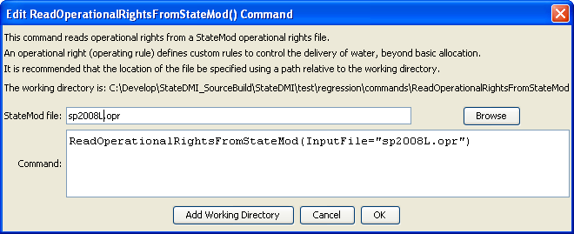
ReadOperationalRightsFromStateMod
ReadOperationalRightsFromStateMod() Command Editor

The command syntax is as follows:

ReadOperationalRightsFromStateMod(Parameter=Value,…)

Command Parameters

Parameter | Description | Default
InputFile | The name of the StateMod operational rights file to read. | None – must be specified.

