Command Reference: ReadPlanReturnFromStateMod()

Read plan return flow data from a StateMod plan return flow file

StateMod Command
Version 3.12.00, 2011-01-02

The ReadPlanReturnFromStateMod() command reads a list of plan return flow data from a StateMod plan return flow data file. The data can then be manipulated and output with other commands.

The following dialog is used to edit the command and illustrates the syntax of the command.

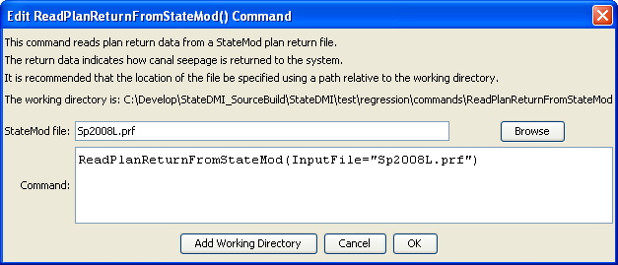
ReadPlanReturnFromStateMod
ReadPlanReturnFromStateMod() Command Editor

The command syntax is as follows:

ReadPlanReturnFromStateMod(Parameter=Value,…)

Command Parameters

Parameter | Description | Default
InputFile | The name of the StateMod plan return flow file to read. | None – must be specified.

