Command Reference: ReadPlanStationsFromStateMod()

Read plan station data from a StateMod plan stations file

StateMod Command
Version 3.12.00, 2010-12-14

The ReadPlanStationsFromStateMod() command reads a list of plan stations from a StateMod plan stations file and defines plan stations in memory. The plan stations can then be manipulated and output with other commands. Comments immediately prior to a plan’s data records are associated with the plan and will be output when the plan stations are written with a WritePlanStationsToStateMod() command.

The following dialog is used to edit the command and illustrates the syntax of the command.

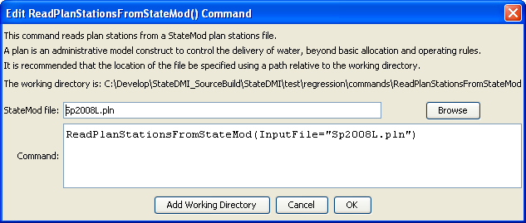
ReadPlanStationsFromStateMod
ReadPlanStationsFromStateMod() Command Editor

The command syntax is as follows:

ReadPlanStationsFromStateMod(Parameter=Value,…)

Command Parameters

Parameter | Description | Default
InputFile | The name of the StateMod plan stations file to read. | None – must be specified.

