Command Reference: ReadPlanWellAugmentationFromStateMod()

Read well augmentation plan data from a StateMod well augmentation plan data file

StateMod Command
Version 3.12.00, 2011-01-02

The ReadPlanWellAugmentationFromStateMod() command reads well augmentation plan data from a StateMod well augmentation plan data file. The data can then be manipulated and output with other commands.

The following dialog is used to edit the command and illustrates the syntax of the command.

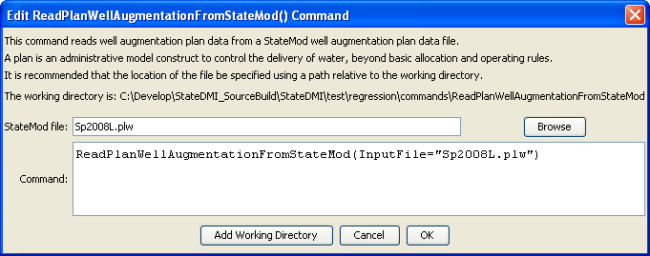
ReadPlanWellAugmentationFromStateMod
ReadPlanWellAugmentationFromStateMod() Command Editor

The command syntax is as follows:

ReadPlanWellAugmentationFromStateMod(Parameter=Value,…)

Command Parameters

Parameter | Description | Default
InputFile | The name of the StateMod well augmentation plan file to read. | None – must be specified.

