Command Reference: ReadReservoirReturnFromStateMod()

Read reservoir return flow data from a StateMod reservoir return flow file

StateMod Command
Version 3.12.00, 2011-01-02

The ReadReservoirReturnFromStateMod() command reads a list of reservoir return flow data from a StateMod reservoir return flow data file. The data can then be manipulated and output with other commands.

The following dialog is used to edit the command and illustrates the syntax of the command.

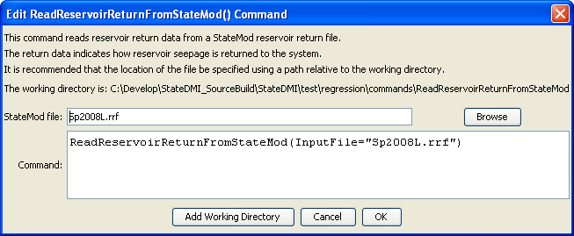
ReadReservoirReturnFromStateMod
ReadReservoirReturnFromStateMod() Command Editor

The command syntax is as follows:

ReadReservoirReturnFromStateMod(Parameter=Value,…)

Command Parameters

Parameter | Description | Default
InputFile | The name of the StateMod reservoir return flow file to read. | None – must be specified.

