Command Reference: ReadReservoirRightsFromStateMod()

Read reservoir right data from a StateMod reservoir rights file

StateMod Command
Version 3.09.01, 2010-02-01

The ReadReservoirRightsFromStateMod() command reads reservoir rights from a StateMod reservoir rights file. The reservoir rights can then be manipulated and output with other commands.

The following dialog is used to edit the command and illustrates the syntax of the command.

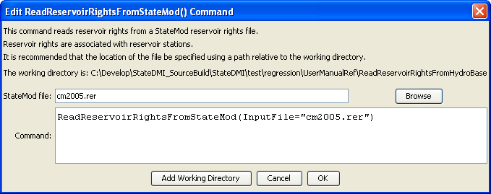
ReadReservoirRightsFromStateMod
ReadReservoirRightsFromStateMod() Command Editor

The command syntax is as follows:

ReadReservoirRightsFromStateMod(Parameter=Value,…)

Command Parameters

Parameter | Description | Default
InputFile | The name of the StateMod reservoir rights file to read. | None – must be specified.

