Command Reference: ReadReservoirStationsFromList()

Read reservoir stations data from a list file

StateMod Command
Version 3.09.01, 2010-02-01

The ReadReservoirStationsFromList() command reads a list of reservoir stations from a delimited list file and defines reservoir stations in memory. The reservoir stations can then be manipulated and output with other commands. The following dialog is used to edit the command and illustrates the syntax of the command.

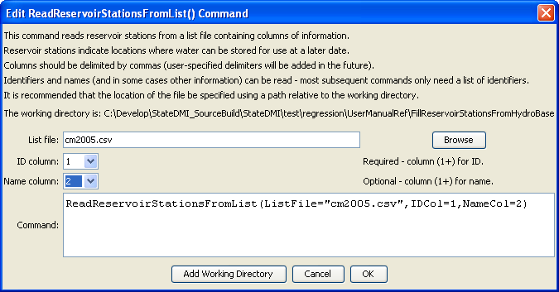
ReadReservoirStationsFromList
ReadReservoirStationsFromList() Command Editor

The command syntax is as follows:

ReadReservoirStationsFromList(Parameter=Value,…)

Command Parameters

Parameter | Description | Default
ListFile | The name of the list file to be read. | None – must be specified.
IDCol | The column number (1+) containing the reservoir station identifiers. | None – must be specified.
NameCol | The column number (1+) containing the reservoir station names. | None – optional (name will be initialized to blank).

At a minimum, the list file must contain a column with diversion station identifiers. Lines starting with the # character are treated as comments. If the first line’s values are surrounded by double quotes, the line is assumed to indicate column headings.

A sample list file is shown below:

# Reservoir stations as a list file
#
"ID”,"Name"
203536,”Reservoir 1”
203558,”Reservoir 2”
…

