Command Reference: ReadReservoirStationsFromNetwork()

Read reservoir station data from a network file

StateMod Command
Version 3.09.01, 2010-02-01

The ReadReservoirStationsFromNetwork() command reads a list of reservoir stations from a StateMod network file (XML or older Makenet network file) and defines reservoir stations in memory. The reservoir stations can then be manipulated and output with other commands.

The following dialog is used to edit the command and illustrates the syntax of the command.

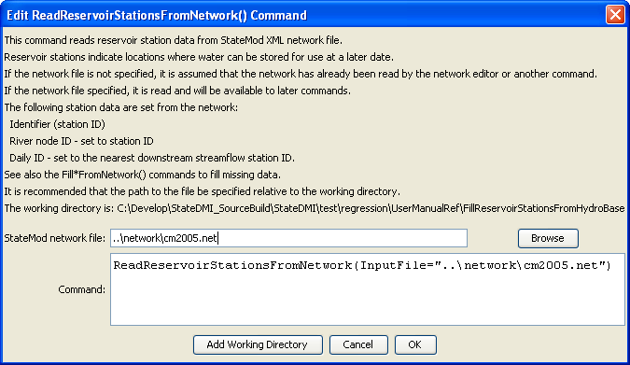
ReadReservoirStationsFromNetwork
ReadReservoirStationsFromNetwork() Command Editor

The command syntax is as follows:

ReadReservoirStationsFromNetwork(Parameter=Value,…)

Command Parameters

Parameter | Description | Default
InputFile | The name of the network file to be read. | None – must be specified.

