Command Reference: ReadReservoirStationsFromStateMod()

Read reservoir station data from a StateMod reservoir stations file

StateMod Command
Version 3.09.01, 2010-02-01

The ReadReservoirStationsFromStateMod() command reads a list of reservoir stations from a StateMod reservoir stations file and defines reservoir stations in memory. The reservoir stations can then be manipulated and output with other commands.

The following dialog is used to edit the command and illustrates the syntax of the command.

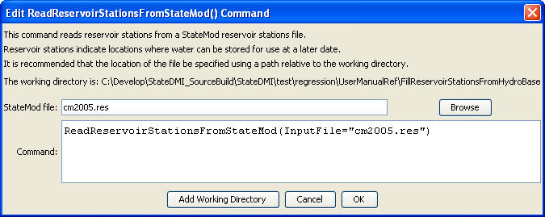
ReadReservoirStationsFromStateMod
ReadReservoirStationsFromStateMod() Command Editor

The command syntax is as follows:

ReadReservoirStationsFromStateMod(Parameter=Value,…)

Command Parameters

Parameter | Description | Default
InputFile | The name of the StateMod reservoir stations file to be read. | None – must be specified.

