Command Reference: ReadResponseFromStateMod()

Read response file data from a StateMod response file

StateMod Command
Version 3.12.00, 2011-01-17

The ReadResponseFromStateMod() command reads a StateMod response file, which contains the list of files in a data set. The primary purpose of this command currently is to facilitate software testing of reading and writing the response file; however, in the future the functionality may be enhanced. The response file can be written using the WriteResponseToStateMod() command.

The following dialog is used to edit the command and illustrates the syntax of the command.

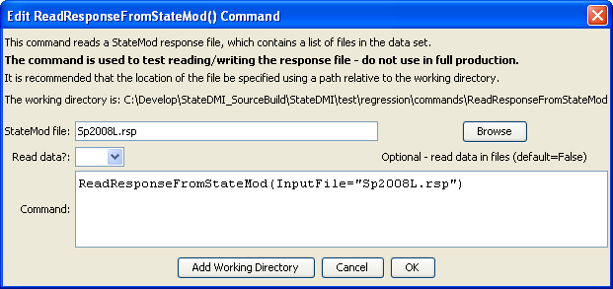
ReadResponseFromStateMod
ReadResponseFromStateMod() Command Editor

The command syntax is as follows:

ReadResponseFromStateMod(Parameter=Value,…)

Command Parameters

Parameter | Description | Default
InputFile | The name of the StateMod response file to read. | None – must be specified.

