Command Reference: ReadStreamEstimateCoefficientsFromStateMod()

Read stream estimate coefficient data from a StateMod stream estimate coefficients file

StateMod Command
Version 3.09.01, 2010-02-01

The ReadStreamEstimateCoefficientsFromStateMod() command reads stream estimate coefficients from a StateMod stream estimate coefficients file. This information is associated with stream estimate stations using the station identifier as the lookup. Stream estimate coefficients define how streamflow is estimated at ungaged locations (stream estimate stations). The stream estimate coefficients that are read can be manipulated and output with other commands.

The following dialog is used to edit the command and illustrates the syntax of the command.

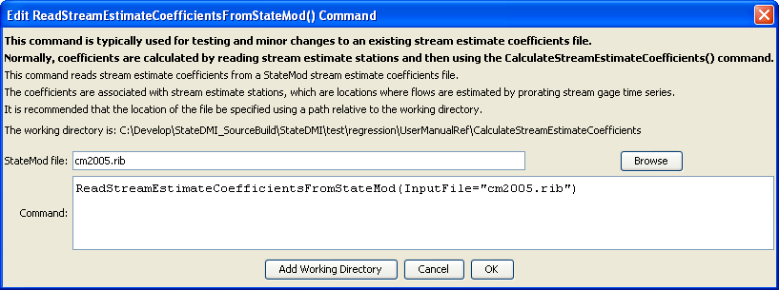
ReadStreamEstimateCoefficientsFromStateMod
ReadStreamEstimateCoefficientsFromStateMod() Command Editor

The command syntax is as follows:

ReadStreamEstimateCoefficientsFromStateMod(Parameter=Value,…)

Command Parameters

Parameter | Description | Default
InputFile | The name of the StateMod stream estimate coefficients file to be read. | None – must be specified.

