Command Reference: ReadStreamEstimateStationsFromList()

Read stream estimate stations data from a list file

StateMod Command
Version 3.09.01, 2010-02-01

The ReadStreamEstimateStationsFromList() command reads a list of stream estimate stations from a delimited list file and defines stream estimate stations in memory. The stream estimate stations can then be manipulated and output with other commands. The following dialog is used to edit the command and illustrates the syntax of the command.

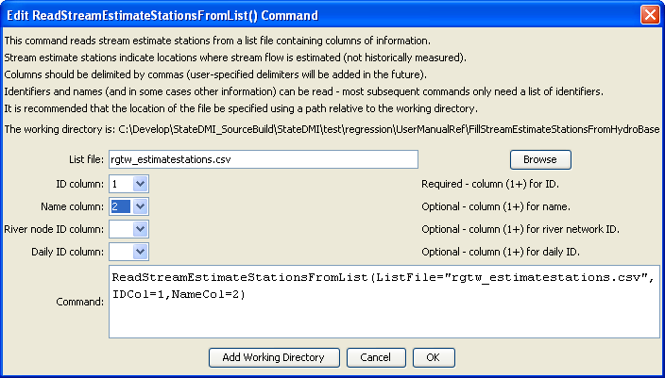
ReadStreamEstimateStationsFromList
ReadStreamEstimateStationsFromList() Command Editor

The command syntax is as follows:

ReadStreamEstimateStationsFromList(Parameter=Value,…)

Command Parameters

Parameter | Description | Default
ListFile | The name of the list file to be read. | None – must be specified.
IDCol | The column number (1+) containing the stream estimate station identifiers. | None – must be specified.
NameCol | The column number (1+) containing the stream estimate station names. | If not specified, set to blank.
RiverNodeIDCol | The column number (1+) containing the river node identifier. | If not specified, set to blank.
DailyIDCol | The column number (1+) containing the daily identifier (for estimating time series). | If not specified, set to blank.

At a minimum, the list file must contain a column with stream estimate station identifiers. Lines starting with the # character are treated as comments. If the first line’s values are surrounded by double quotes, the line is assumed to indicate column headings.

A sample list file is shown below:

# Stream estimate stations as a list file
#
"ID”,"Name"
NF1,”Natural flow 1”
NF2,”Natural flow 2”
…

