Command Reference: ReadStreamEstimateStationsFromNetwork()

Read stream estimate station data from a network file

StateMod Command
Version 3.09.01, 2010-02-01

The ReadStreamEstimateStationsFromNetwork() command reads a list of stream estimate stations from a StateMod network file (XML or Makenet) and defines stream estimate stations in memory. Stream estimate stations are stations not of type FLOW but which are indicated as natural flow nodes in the network. The default output order is that of the stream network, upstream to downstream. The StateMod model requires that the stream gage station file be in the same order as the river network file. The stream estimate stations that are read can be manipulated and output with other commands.

The following dialog is used to edit the command and illustrates the syntax of the command.

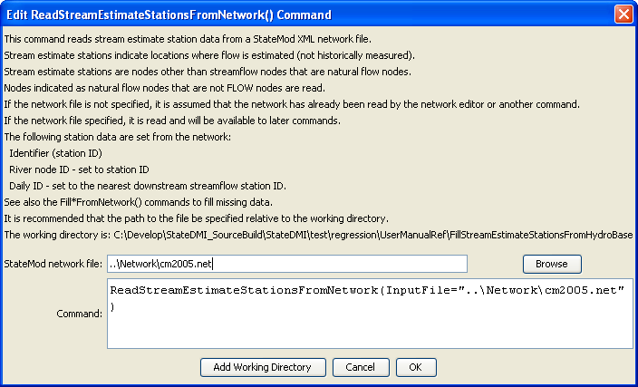
ReadStreamEstimateStationsFromNetwork
ReadStreamEstimateStationsFromNetwork() Command Editor

The command syntax is as follows:

ReadStreamEstimateStationsFromNetwork(Parameter=Value,…)

Command Parameters

Parameter | Description | Default
InputFile | The name of the network file to be read. | Use the network that has previously been read with other commands.

