Command Reference: ReadStreamEstimateStationsFromStateMod()

Read stream estimate station data from a StateMod stream estimate stations file

StateMod Command
Version 3.09.01, 2010-02-01

The ReadStreamEstimateStationsFromStateMod() command reads a list of stream estimate stations from a StateMod stream estimate stations file and defines stream estimate stations in memory. The stream estimate stations can then be manipulated and output with other commands.

The following dialog is used to edit the command and illustrates the syntax of the command.

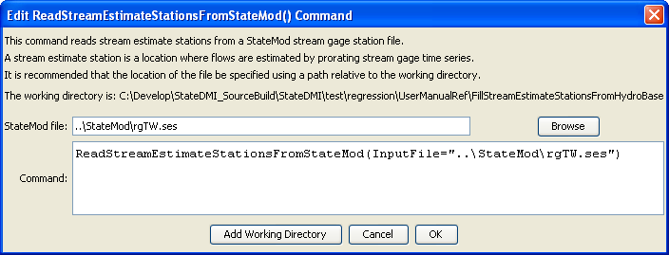
ReadStreamEstimateStationsFromStateMod
ReadStreamEstimateStationsFromStateMod() Command Editor

The command syntax is as follows:

ReadStreamEstimateStationsFromStateMod(Parameter=Value,…)

Command Parameters

Parameter | Description | Default
InputFile | The name of the StateMod stream estimate stations file to be read. | None – must be specified.

