Command Reference: ReadStreamGageStationsFromStateMod()

Read stream gage station data from a StateMod stream gage stations file

StateMod Command
Version 3.09.01, 2010-02-01

The ReadStreamGageStationsFromStateMod() command reads a list of stream gage stations from a StateMod stream gage stations file and defines stream gage stations in memory. The stream gage stations can then be manipulated and output with other commands.

The following dialog is used to edit the command and illustrates the syntax of the command.

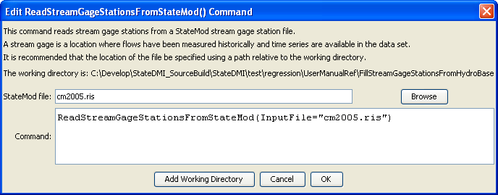
ReadStreamGageStationsFromStateMod
ReadStreamGageStationsFromStateMod() Command Editor

The command syntax is as follows:

ReadStreamGageStationsFromStateMod(Parameter=Value,…)

Command Parameters

Parameter | Description | Default
InputFile | The name of the StateMod stream gage stations file to be read. | None – must be specified.

