Command Reference: ReadWellHistoricalPumpingTSMonthlyFromStateCU()

Read well historical pumping time series (monthly) data from a StateCU file

StateCU and StateMod Command
Version 3.09.00, 2010-01-26

The ReadWellHistoricalPumpingTSMonthlyFromStateCU() command reads well historical pumping time series (monthly) and defines the data in memory. This command is used when estimating average efficiencies and calculating demand time series. All time series are read, whether or not they match the list of well stations. This command is equivalent to the ReadWellHistoricalPumpingTSMonthlyFromStateMod() command – use the commands as appropriate depending on which data set file is being read (the file format is the StateMod time series file format).

The following dialog is used to edit the command and illustrates the syntax of the command.

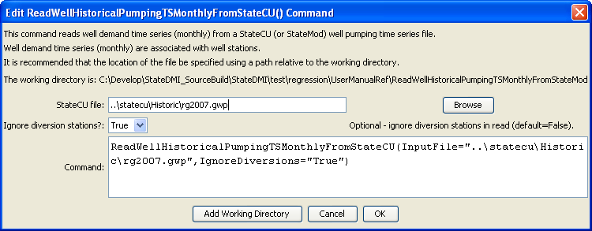
ReadWellHistoricalPumpingTSMonnthlyFromStateCU
ReadWellHistoricalPumpingTSMonthlyFromStateCU() Command Editor

The command syntax is as follows:

ReadWellHisoricalPumpingTSMonthlyFromStateCU(Parameter=Value,…)

Command Parameters

Parameter | Description | Default
InputFile | The name of the well historical pumping time series (monthly) file to read. | None – must be specified.

