Command Reference: ReadWellRightsFromStateMod()

Read well right data from a StateMod well rights file

StateCU and StateMod Command
Version 3.09.00, 2010-01-00

The ReadWellRightsFromStateMod() command reads well rights from a StateMod well rights file. The well rights can then be manipulated and output with other commands. Current procedures for processing some data files involve utilizing StateMod well rights file(s) as input rather than rereading well rights from HydroBase. This ensures that the content and quality of the well rights file can be verified and is used consistently when processing various model files. For example, StateMod well rights files may be used for the following purposes:

- Turning off groundwater only parcels irrigated lands (crop pattern and irrigation practice acreage time series) prior to a specific year of parcel data. Parcels that do not have a well right in a year are estimated to not be irrigated for the year (and prior years). This step typically uses a well rights file that has NOT had water rights for various parcel years merged – data for a single parcel year will be used. See the WriteWellRightsToStateMod(…,WriteDataComments=True,…) command.
- Setting the pumping maximum in the irrigation practice time series. This step typically uses a well rights file that includes well rights for different parcel years that have been merged. For example, well rights from 1998 parcels and those from 2002 parcels are merged to not double count rights. See the MergeWellRights() command.
- Setting the well station capacity to the total of the well rights. This step may use a merged rights file or one that has been aggregated (well rights summed into administration number classes). Aggregation is used in some data sets to decrease the complexity of the model. However, aggregation is generally NOT performed in data sets such as the South Platte where augmentation plans reference individual well rights. See the AggregateWellRights() command.

The well rights files mentioned above are typically written to separate files with unique names. To support cases 1 and 2 above, the StateMod file should include “data comments” on the far right, which include the well to parcel matching data (parcel year, class, parcel ID). An excerpt from a well rights file with this information is shown below:

#> ID Name Struct Admin # Decree On/Off PYr--Cls--PID
#>---------eb----------------------eb----------eb--------------eb------eb------exb--exb--exb----e
#>
#>
2005001 W0006 WELL NO 01 200812 31592.00000 2.34 1936 1936 1 3107
2005001 W0006 WELL NO 01 200812 38836.00000 1.23 1956 1936 1 3107
2005001 W0006 WELL NO 01 200812 31592.00000 2.34 1936 1998 2 11016
2005001 W0006 WELL NO 01 200812 38836.00000 1.23 1956 1998 2 11016
2005001 W0006 WELL NO 01 200812 31592.00000 1.19 1936 2002 2 20901
2005001 W0006 WELL NO 01 200812 38836.00000 0.62 1956 2002 2 20901
2005001 W0006 WELL NO 01 200812 31592.00000 1.15 1936 2002 5 20902
2005001 W0006 WELL NO 01 200812 38836.00000 0.61 1956 2002 5 20902

The following dialog is used to edit the command and illustrates the syntax of the command.

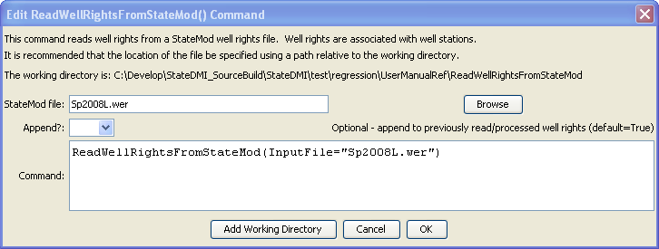
ReadWellRightsFromStateMod
ReadWellRightsFromStateMod() Command Editor

The command syntax is as follows:

ReadWellRightsFromStateMod(Parameter=Value,…)

Command Parameters

Parameter | Description | Default
InputFile | The name of the StateMod well rights file to be read. | None – must be specified.
Append | Indicate whether the data should be appended to in-memory well rights. Specify False if processing well rights for independent tasks and the current task should not be influenced by previously read well rights. | True

