Command Reference: ReadWellStationsFromList()

Read well stations data from a list file

StateMod Command
Version 3.09.00, 2010-01-24

The ReadWellStationsFromList() command reads a list of well stations from a delimited list file and defines well stations in memory. The well stations can then be manipulated and output with other commands. Reading from a list is more general than reading from a StateMod file.

The following dialog is used to edit the command and illustrates the syntax of the command.

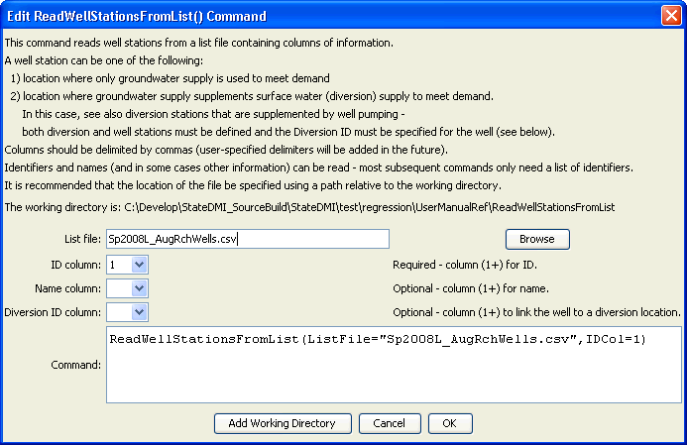
ReadWellStationsFromList
ReadWellStationsFromList() Command Editor

The command syntax is as follows:

ReadWellStationsFromList(Parameter=Value,…)

Command Parameters

Parameter | Description | Default
ListFile | The name of the list file to be read. | None – must be specified.
IDCol | The column number (1+) containing the well station identifiers. | None – must be specified.
NameCol | The column number (1+) containing the well station names. | None – optional (name will be initialized to blank).
DiversionIDCol | The column number (1+) containing the diversion identifiers associated with the well stations. This is needed in some cases to determine when a location is a diversion with supplemental well supply, for example, when processing well rights. | None – optional (diversion ID will be initialized to blank).

At a minimum, the list file must contain a column with well station identifiers. Lines starting with the # character are treated as comments. If the first line’s values are surrounded by double quotes, the line is assumed to indicate column headings.

A sample list file is shown below:

#
# sp2007L_AugRchWells.csv
# _______________________________________________________
#
# rrb Augmentation and recharge wells from SmOpr
# SmOpr
# State of Colorado
# Version: 1.00
# Last revision date: 2006/10/27
#
# rrb 2008/10/08 count = 17 + 4 21
# _______________________________________________________
#
0102522_AuW ,"RIVERSIDE AUG ",' ', ' ', ' ', ' ', ' ','NA'
0102528_AuW ,"FT MORGAN CNL AUG PLAN ",' ', ' ', ' ', ' ', ' ','NA'
0102529_AuW ,"UPPER PLATTE BEAVER AUG ",' ', ' ', ' ', ' ', ' ','NA'
0102535_ReW ,"LOWER PLATTE BEAVER AUG ",' ', ' ', ' ', ' ', ' ','NA'
0102535_AuW ,"LOWER PLATTE BEAVER AUG ",' ', ' ', ' ', ' ', ' ','NA'
6402015_ReW ,"TAMARAK ",' ', ' ', ' ', ' ', ' ','NA'
6402027_ReW ,"OVERLAND ",' ', ' ', ' ', ' ', ' ','NA'
6402518_AuW ,"HARMONY Aug Well ",' ', ' ', ' ', ' ', ' ','NA'
6402519_ReW ,"DINSDALE AUG ",' ', ' ', ' ', ' ', ' ','NA'
…

