Command Reference: ReadWellStationsFromNetwork()

Read well station data from a network file

StateCU and StateMod Command
Version 3.09.00, 2010-01-25

The ReadWellStationsFromNetwork() command reads a list of well stations from a StateMod network file (XML or Makenet) and defines well stations in memory. The well stations can then be manipulated and output with other commands.

The following dialog is used to edit the command and illustrates the syntax of the command.

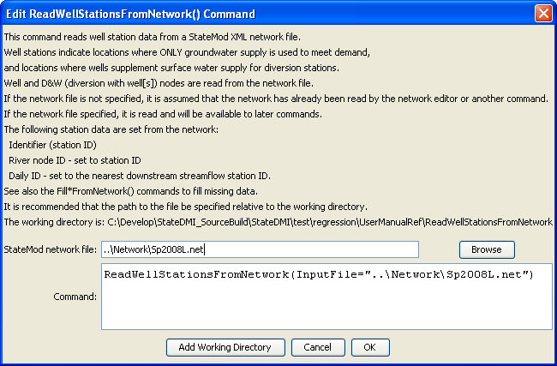
ReadWellStationsFromNetwork
ReadWellStationsFromNetwork() Command Editor

The command syntax is as follows:

ReadWellStationsFromNetwork(param=value,…)

Command Parameters

Parameter | Description | Default
InputFile | The name of the network file to read. | None – must be specified.

The following example command file illustrates how well rights can be defined, sorted, checked, and written to a StateMod file:

# Well Rights File (*.wer)
#
StartLog(LogFile="Sp2008L_WER.log")
# _________________________________________________________
# Step 1 - Read all structures
#
ReadWellStationsFromNetwork(InputFile="..\Network\Sp2008L.net")
SortWellStations()
# _________________________________________________________
# Step 2 - define diversion and d&w aggregates and demand systems
SetWellAggregateFromList(ListFile="..\Sp2008L_SWAgg.csv",PartType=Ditch,IDCol=1,
NameCol=2,PartIDsCol=3,PartsListedHow=InColumn,IfNotFound=Warn)
SetWellSystemFromList(ListFile="..\Sp2008L_DivSys_DDH.csv",PartType=Ditch,IDCol=1,
NameCol=2,PartIDsCol=3,PartsListedHow=InRow,IfNotFound=Warn)
#
SetWellAggregateFromList(ListFile="Sp2008L_AugRchWell_Aggregates.csv",PartType=Well,
IDCol=1,PartIDsCol=2,PartsListedHow=InRow)
# _________________________________________________________
# Step 3- Set Well aggregates (GW Only lands)
# rrb Same as provided by LRE as Sp_GWAgg_xxxx.csv except non WD 01 and 64 removed
SetWellSystemFromList(ListFile="..\Sp2008L_GWAgg_1956.csv",Year=1956,Div=1,
PartType=Parcel,IDCol=1,PartIDsCol=2,PartsListedHow=InColumn)
SetWellSystemFromList(ListFile="..\Sp2008L_GWAgg_1976.csv",Year=1976,Div=1,
PartType=Parcel,IDCol=1,PartIDsCol=2,PartsListedHow=InColumn)
SetWellSystemFromList(ListFile="..\Sp2008L_GWAgg_1987.csv",Year=1987,Div=1,
PartType=Parcel,IDCol=1,PartIDsCol=2,PartsListedHow=InColumn)
SetWellSystemFromList(ListFile="..\Sp2008L_GWAgg_2001.csv",Year=2001,Div=1,
PartType=Parcel,IDCol=1,PartIDsCol=2,PartsListedHow=InColumn)
SetWellSystemFromList(ListFile="..\Sp2008L_GWAgg_2005.csv",Year=2005,Div=1,
PartType=Parcel,IDCol=1,PartIDsCol=2,PartsListedHow=InColumn)
# _________________________________________________________
# Step 4 - Read Augmentation and Recharge Well Aggregate Parts
SetWellAggregateFromList(ListFile="Sp2008L_AugRchWell_Aggregates.csv",PartType=Well,
IDCol=1,PartIDsCol=2,PartsListedHow=InRow,PartIDsColMax=25,IfNotFound=Ignore)
SetWellAggregateFromList(ListFile="Sp2008L_AlternatePoint_Aggregates.csv",PartType=Well,
IDCol=1,PartIDsCol=2,PartsListedHow=InRow,PartIDsColMax=1,IfNotFound=Ignore)
# _________________________________________________________
# Step 5 - Read rights from HydroBase
ReadWellRightsFromHydroBase(ID="*",IDFormat="HydroBaseID",Year="1956,1976,1987,2001,2005",
Div="1",DefaultAppropriationDate="1950-01-01",DefineRightHow=RightIfAvailable,
ReadWellRights=True,UseApex=True,OnOffDefault=AppropriationDate)
# _________________________________________________________
# Step 6 - Sort and Write
# Write Data Comments="True" provides output used for subsequent cds & ipy acreage filling
# Write Data Comments="False" provides merged file used for seting ipy max pumping
SortWellRights(Order=LocationIDAscending,Order2=IDAscending)
# _________________________________________________________
WriteWellRightsToStateMod(OutputFile="Sp2008L_NotMerged.wer",WriteDataComments=True)
MergeWellRights(OutputFile="..\StateMod\Historic\Sp2008L.wer")
SortWellRights(Order=LocationIDAscending,Order2=IDAscending)
# _________________________________________________________
WriteWellRightsToStateMod(OutputFile="Sp2008L.wer",
WriteDataComments=False,WriteHow=OverwriteFile)
# Check the well rights
CheckWellRights(ID="*")
WriteCheckFile(OutputFile="Sp2008L.wer.check.html",Title="Well Rights Check File")

