Command Reference: ReadWellStationsFromStateMod()

Read well station data from a StateMod well stations file

StateCU and StateMod Command
Version 3.09.00, 2010-01-24

The ReadWellStationsFromStateMod() command reads a list of well stations from a StateMod well stations file and defines well stations in memory. The well stations can then be manipulated and output with other commands. The StateMod well stations file contains stations for which only groundwater supply is available and stations for which groundwater supply supplements surface water supply of a diversion station (in this case the well station data includes the diversion station identifier). For some data (e.g., demands), StateMod accepts data from multiple files. For example, diversion and diversion+well stations may read total demands from the diversion demands file and well (groundwater only) stations may read demands from the well demands file. Parameters are available in this command to read all well stations or only a subset, to allow flexibility in data processing. Other commands may also process a subset, regardless of what is read.

The following dialog is used to edit the command and illustrates the syntax of the command.

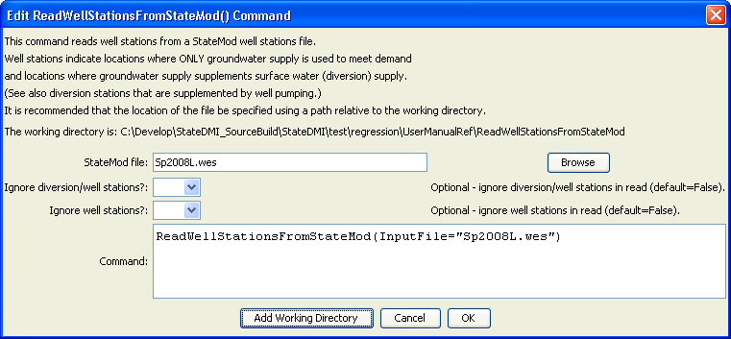
ReadWellStationsFromStateMod
ReadWellStationsFromStateMod() Command Editor

The command syntax is as follows:

ReadWellStationsFromStateMod(Parameter=Value,…)

Command Parameters

Parameter | Description | Default
InputFile | The name of the StateMod well stations file to be read. | None – must be specified.
IgnoreDWs | Indicate whether the D&W well nodes should be ignored. These are locations where well supply supplements surface water (diversion) supply. | False
IgnoreWells | Indicate whether the well nodes should be ignored. These are locations where only well supply is used. | False

